Guys, I beg you, with questions, additions, hooters ... - in a working theme ,
Thank you for understanding.
I will say at once, I am very far from programming, and this design has appeared thanks to the help of excellent programmers from our forum and just good people, I will not list them, that I would not forget anyone, but to all of them Thank you very much.
Principle of operation:
On the spindle - the encoder (driving gear), on the lead screw - the stepper motor (driven gear), between them the electronic reducer with variable reduction ratio, the encoder pulses are divided by the reduction ratio - we receive pulses for the driver of the peg.
In this article we used:
Arduino Mega2560 (controller itself)
Prototype Board for Adduino (layout for additional items)
LCD Keypad Shield (keyboard + screen) Currently replaced by a separate LCD1602 and buttons
The Chinese stepper, currently on the longitudinal Leadshine 86HS35, on the transverse Nema 23, 57x76, 18.9 kg / cm
Chinese driver Sh.D. (2M542) , Currently replaced by Leadshine DM556 x 2pcs.
Chinese impulse BP. 36-42V Currently replaced by 48V
A homemade encoder, based on a disk and a sensor, from a dead HP printer.
Written in Arduino 1.0.2 , no third-party libraries are used, this version I recommend to use for repetition.
For today this thing is able:
7 feeds: from 0.03mm to 0.21mm, in increments of 0.03, with spindle speeds up to ~ 2500 rpm
38 threads: from 0.2mm to 3mm in the metric range, from 80tpi to 12tpi in inch, with spindle speeds up to ~ 1800 rpm
Spindle divider: 0.1 degree step, + built-in division calculator
Stopping the carriages by software stops
Output to the external tachometer (1 imp / rev)
Encoder 1800 lines, processed in x2 mode (3600 pulses per revolution)
The thread on the shaft and the nut of the M40X1 (CT45) encoder was cut already with an electric guitar
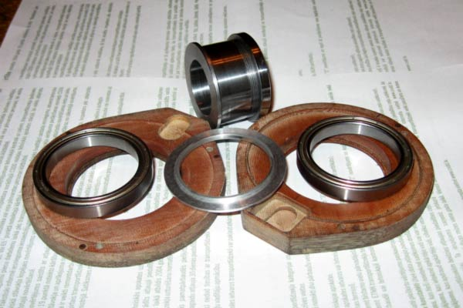
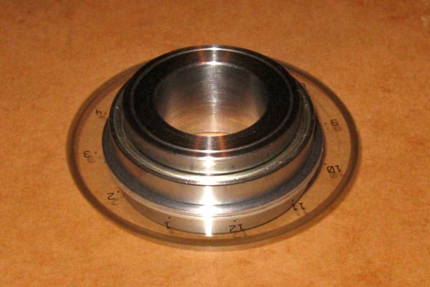
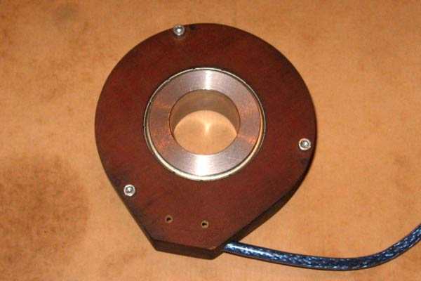

Scheme, scraps, but it seems to be quite readable,
If the output of your encoder is sin / cos, then you need a cascade to convert it to a square wave:
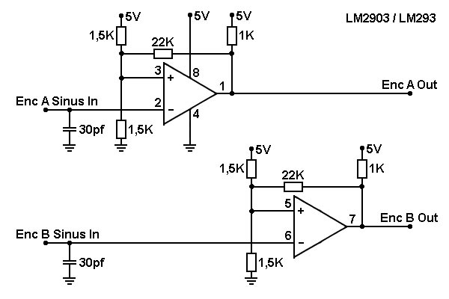

Further the cascade for signal extraction DIR, up to version 6 inclusive:
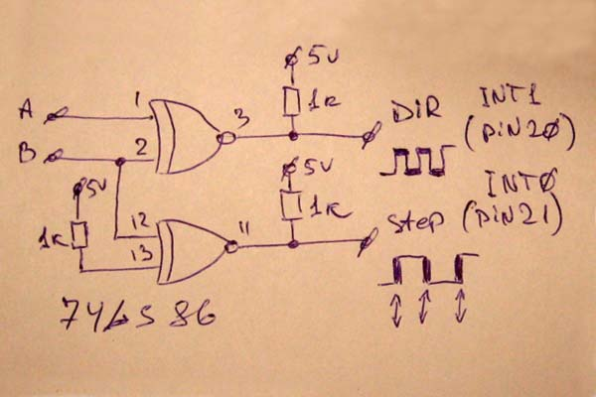

sn74ls86n with 74HC86N or 74HC86D will also work

Here, according to this scheme, everything works. 11 the output of 7486 should be on the 21 conclusion of the Arduin, at 47 it does not work.
If the sensor is not with a sine output, the LM2903 is not needed.

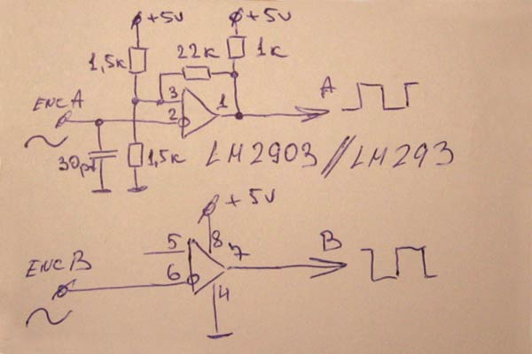

And inputs / outputs:
Joystick (up to version 5a) only left / right is used
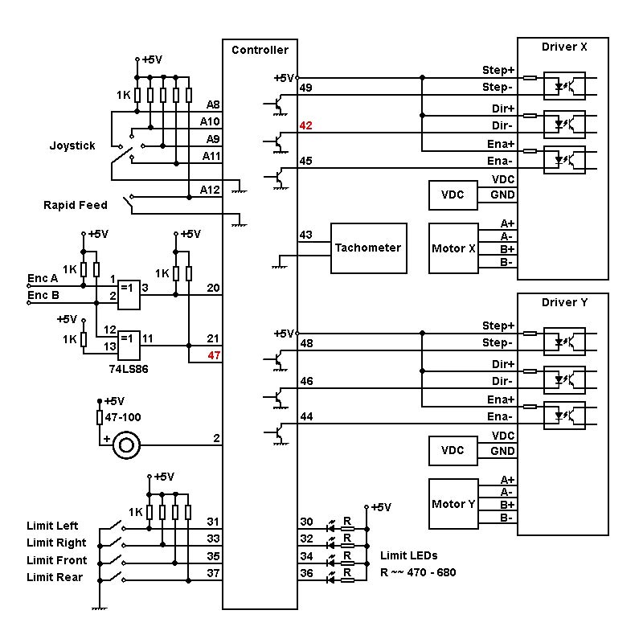

Customization for your hardware:
0. First of all, the phasing of the encoder, with the spindle rotating directly (toward itself), the value of the angle should increase,
If the angle decreases - swap the outputs of the AB encoder.
1. Indicate the number of encoder scribes
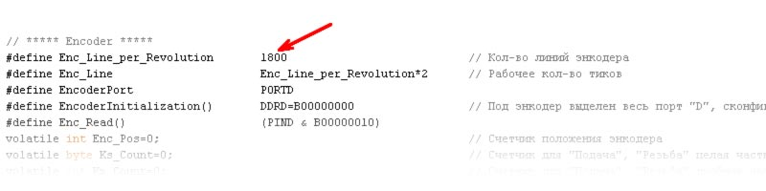
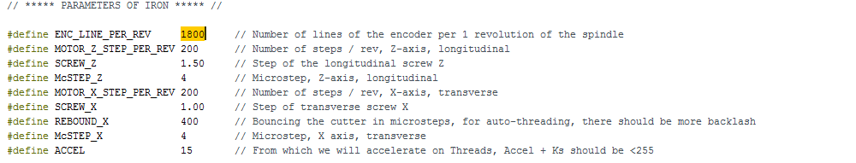

2. Indicate the required number of feeds in the table
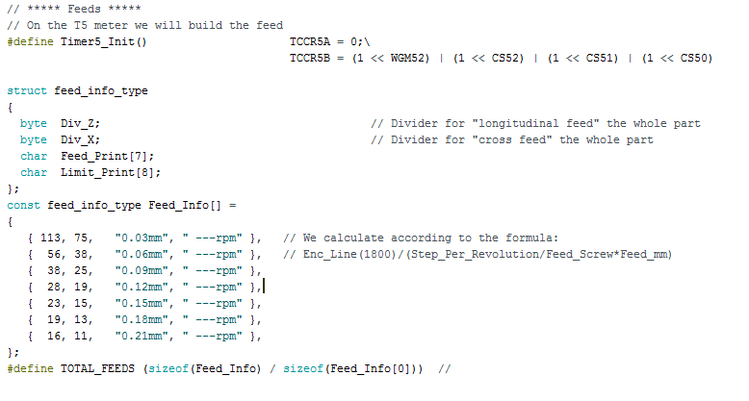

This is a hint at what maximum revs your machine
Able to perform this operation, in the table instead of a dash
Set your values.

3. To recalculate for each step of feedings the factor of division under the formula:
K = Enc_Line / (Step_Per_Revolution / Feed_Screw * Feed_mm)
Where
Enc_Line - number of working pulses from the encoder
Step_Per_Revolution - the number of steps of the engine per revolution of the lead screw
Feed_Screw - spindle pitch
Feed_mm - required feed step
Coefficient. Can not have a value greater than 255
The 2nd column is used for display
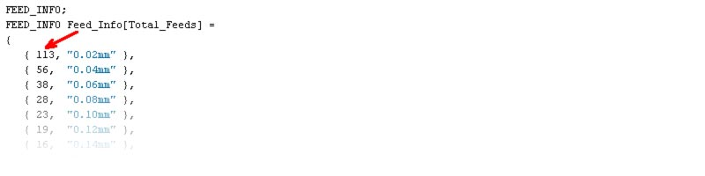

4. Indicate the required number of threads
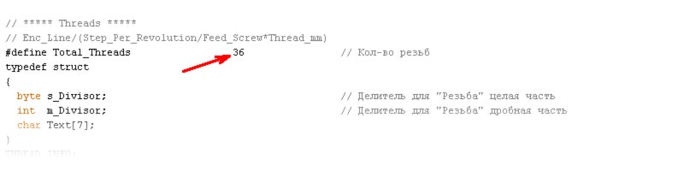
5. To recalculate for each step of threads the coefficient of division according to the formula:
K = Enc_Line / (Step_Per_Revolution / Feed_Screw * Thread_mm)
Where
Enc_Line - number of working pulses from the encoder
Step_Per_Revolution - the number of steps of the engine per revolution of the lead screw
Feed_Screw - spindle pitch
Thread_mm - required thread pitch
The 1st column is the whole part, should lie in the range 1 - 255, (better from 2-3)
2nd column fractional part
3rd column for display

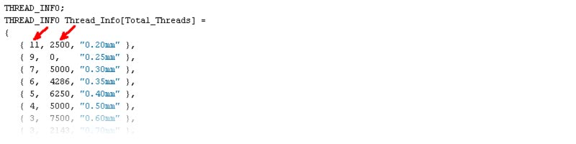
6. Version 3b introduces new parameters for smooth acceleration
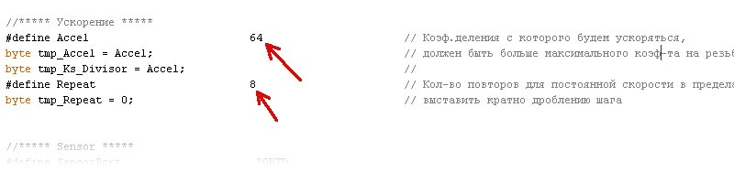
Accel - the higher the value, the longer the acceleration / deceleration,
The value can lie in the range from "maximum divide ratio" to 255
As an example, for this table "Thread" Accel can lie in the range from 33 to 255

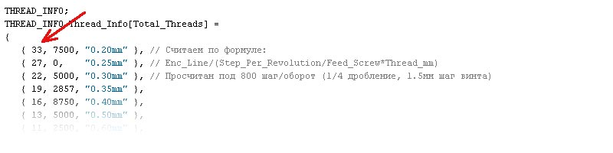
Repeat - for the constancy of speed within a full step,
The value should be a multiple of the step fragmentation,
those. In the above example, the 1/4 crushing (800 steps per revolution), 4 half steps * 2 = 8,
Want a long overclocking - just multiply multiply.

Setting up vrs 5 and vrs 6

We will continue with your help,
47 pins had to be moved, the change on the pins highlighted red (if nothing had been forgotten ),
Scheme for the 5th and 6th versions, buzzer only from version 6c

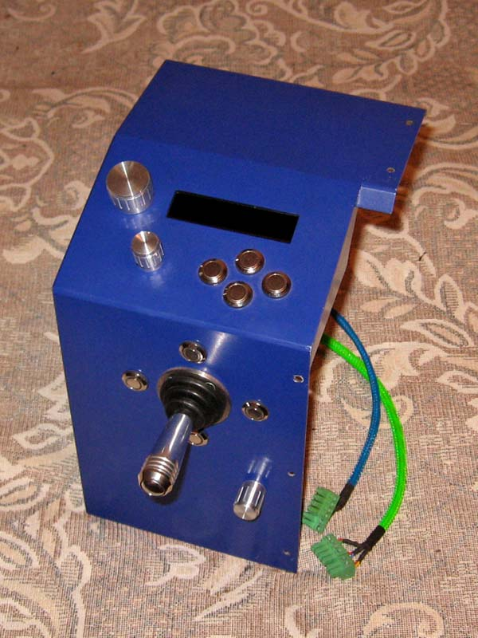

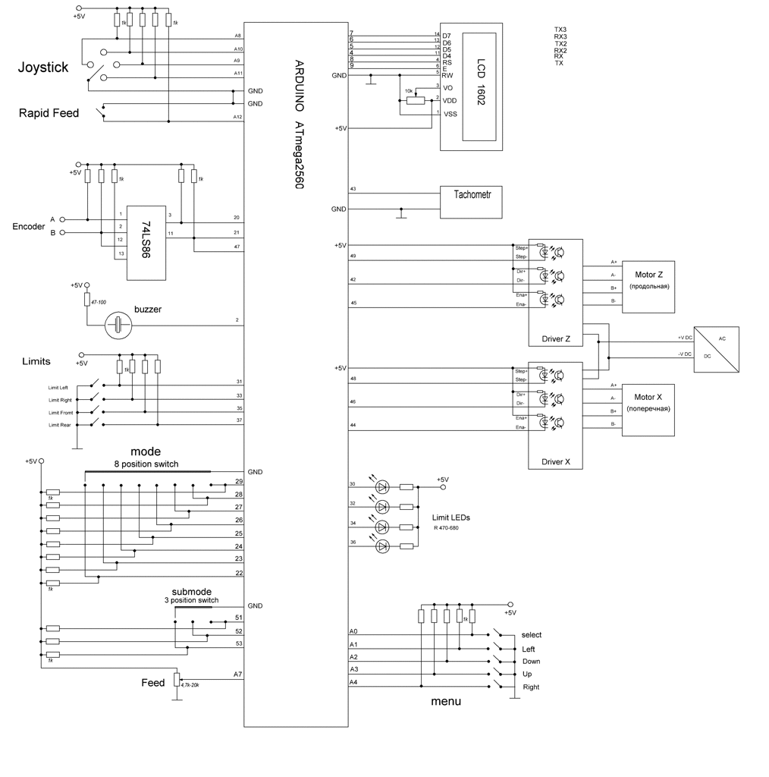
As in the diagram, many people use buttons with built-in LEDs.
As for resets, I wanted to ask myself, I still have an indicator with buttons
And there is, and Mega should have such a pin. Reset by shutdown
Power supply machine as it is not good.
On the tip in the l.m. Found that the scheme does not have LCD and menu buttons,
The scheme will be supplemented later, and who sooo need, it's googled by "LCD KEYPAD SHIELD".
The main changes in the 5th version:
* The ceiling spindle speed in the "Feed" mode is significantly increased.
* There was a cross feed (with all the possibilities longitudinal).
* Acceleration / deceleration is introduced at large pitch steps.
* There was a new mode of "Cone" (so far only one way, we will go further than that).
* In the "Thread" mode, it was possible to go to the right for the established right limit (for fitting the part) and return with the synchronization saved.
* The "Divisor" mode has been changed, the "division calculator" has been introduced more precisely.
Operating procedure
Modes as before switch the "Select" button in a circle: Feed => Cone => Thread => Divider
Feed
In principle, nothing has changed for the user,
The Up-Down buttons change the feed step, it can be changed both on the move and at the neutral position of the joystick,
4-direction feed direction of the joystick,
4-r Direction of fast travel on joystick and button of accelerated,
4-re limit buttons, limits are set only when the joystick is neutral.
A small jamb has been fixed: if we stopped in the acceleration / deceleration zone and we need to get to the nearest limit, then in the new version we will add to the nearest limit at the lowest possible pitch.
Cone
While only one way, the thin end of the spindle (will be further seen).
Use the Up-Down buttons to change the feed step, you can change it on the fly.
Use the buttons Right-Left (with the neutral position of the joystick) to select the cone.
You can set (right-left) or use previously set limits.
Forward-back limits (if they were previously set) are ignored, but their position in memory is saved.
The cutting is switched on by the joystick right-left.
The joystick button is used for accelerated movement, the trajectory is the selected cone.
Joystick Forward-Back is not yet involved (chasing see what to hang on it).
Thread
Use the Up-Down buttons to select the thread pitch, you can change only when the joystick is neutral,
4-direction of the joystick thread, (yes, yes, pampering, but transverse thread )
4-re limit buttons, limits are set only when the joystick is neutral.
When pressing the joystick button, the right stop is ignored, you can go for it arbitrarily,
That would restore the synchronization enough to get to the left stop, continue threading as usual.
Divider
Using the Up-Down buttons, the number of "dividing teeth" (maximum 255) is displayed in the first line of the indicator.
Using the buttons Right-Left move to the next-previous "tooth", the current "tooth" is displayed in the second line of the indicator.
The first line of the indicator shows the required angle for the current "tooth".
In the second line of the indicator, the actual spindle angle is displayed.
All that is required is to turn the spindle to match the readings.
(About a dozen times doing the markup, it seemed quite convenient,
Reset the angle is not provided, but you can hang it on the button of the joystick, that would be difficult to count without losing a count of teeth when resetting the reset).
Settings
Basic, the so-called. iron
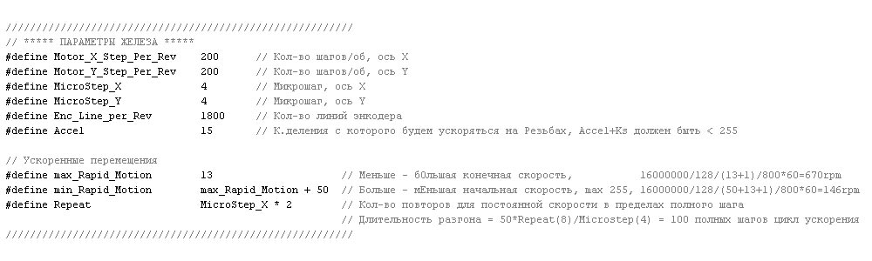
Little has changed here,
No longer need to fill the number of innings, carvings and cones, thanks to fellow countryman Sergey

Feed
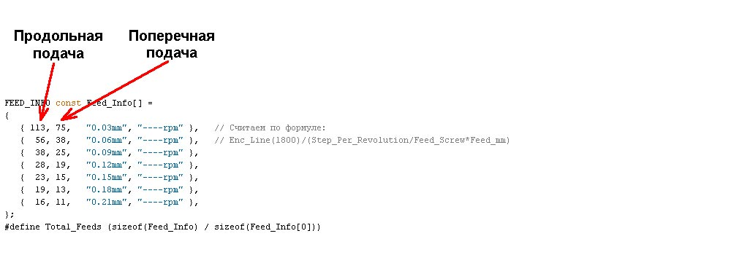
Important! The old coefficients for longitudinal feeding do not fit, we consider it anew.

Cone
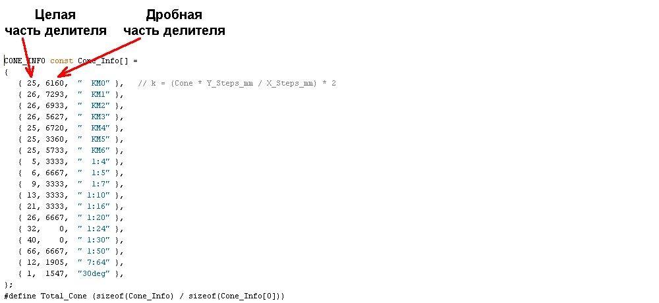
Since Screw longitudinal and transverse have a different step, you need to explain a little and expand the formula,
But however, see the color plate below.

Thread
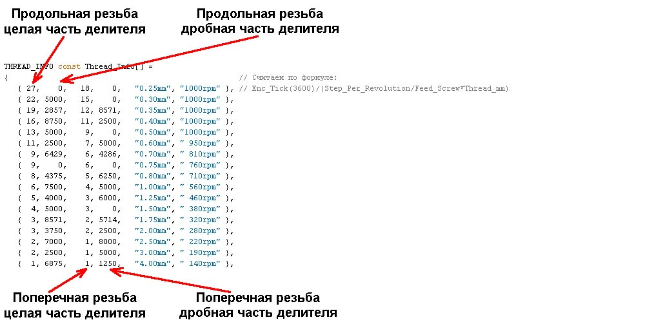

For the longitudinal thread, old coefficients are suitable.
To facilitate the calculation of coefficients in OpenOffice made a tablet,
File in the formats * .ods and * .xls (under excel, nothing works, stupid export) here
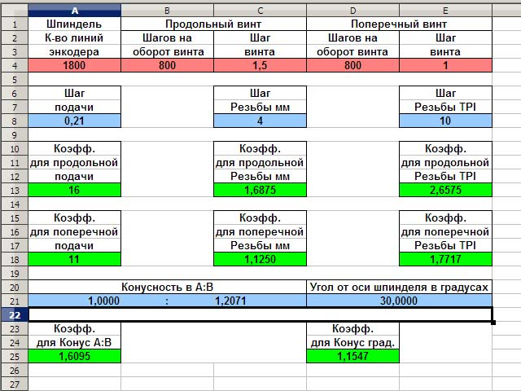

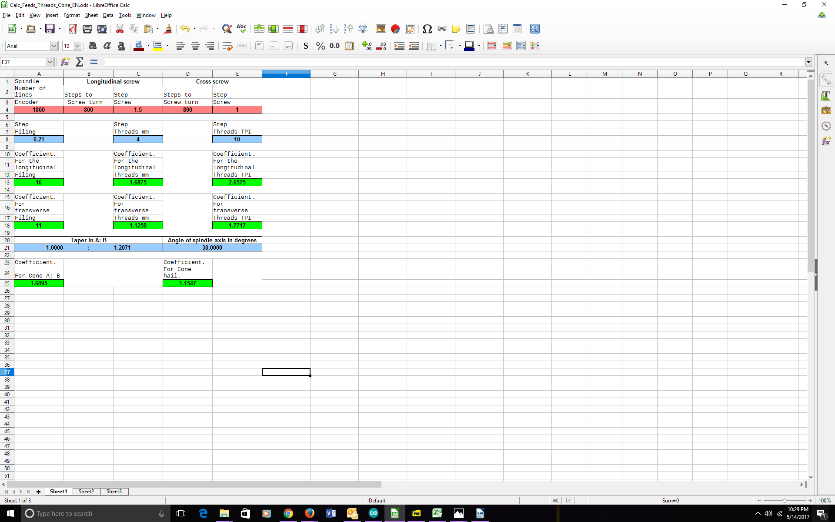

In the pink fields - to score the settings of the iron,
In blue fields - to hammer in the required pitch step, thread pitch, taper or angle,
In green fields - we read the result.

Version 6b_auto, swings by reference from the first message of the topic.
0. Has not passed and ... It took 3 years and I still renamed the axes to the standard
Longitudinal feed - axis Z, transverse - axis X.
For the old users nothing has changed, on which pins the feeds were sitting there and stayed, just glue the labels on the drivers.
It should have been done for a long time, but laziness outweighed.
What's New:
1. Fixed a couple of minor bugs that users would most likely never encounter, but they were possible.
2. The formula for calculating the deceleration start point has been changed; under certain conditions, under certain conditions, there could be a run or a run-in for 1 microstep, it does not seem to be scary, the engine will still fall to the nearest whole position, but it took place.
3. At the request of workers, the possibility of including an accelerated filing in the modes "Submission" and "Cone" after an incomplete operation,
As an example: the joystick was not returned to neutral, and the spindle was stopped, the delay after stopping was ~~0.3sec (if necessary, regulated), he personally did not feel the need, but let while will, if it does not harm anyone, the responsibility for the NS. I'm taking pictures of myself
4. Automatic tapping, internal, external, right, left, from you only preparation of the diameter of the rod or hole,
It is no longer necessary to count the depths and number of passes, the adaptive depth from the current step and passage,
Testing only on the spindle's straight spins, (the order of work is lower), a short old movie, who did not see, I'll duplicate

https://youtu.be/1AhXzZRmozg

In the settings of his "iron" there was a triple of new parameters,
Issues should not be

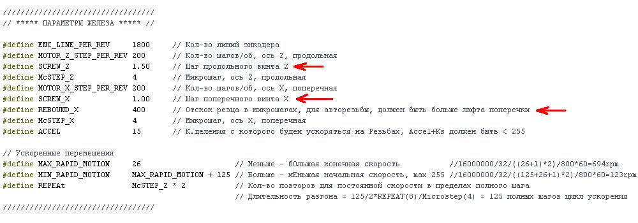

In the thread table, finish off two new columns, the thread pitch and the desired number of passes for each step,
Number of passes at your discretion, the depth of the program will recalculate itself.
I tried to lay with the following calculation, the 1st pass 0.2-0.25mm the extreme 0.07-0.08mm.
To these passages will be added 3 final, who will seem a lot / little whistle will say where to change,
For me it's so like the norm, the first - on the sound still removes, the second - barely audible rustling, the third - maybe not needed.

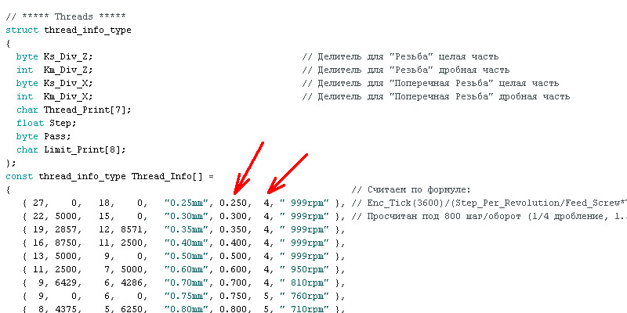

The step is duplicated, I see that it is not beautiful, but I can not imagine how to weed out the inch from the metric
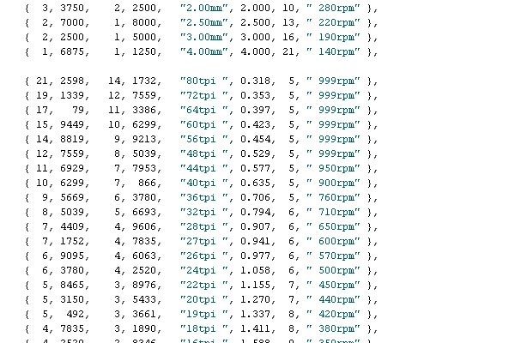

The procedure for working with autocutting:
1. We process the workpiece in size according to GOST-U in any way customary for you
2. If previously did not stand, we put the right and left stop on the required thread length
3. In the thread mode, use the Up / Down buttons to select the desired step
4. Use the Left / Right buttons to select "Outdoor" Ext, or "Internal" Int, (on the middle of the "Manual" Man)
5. On the example of the right-hand thread, the direct spindle turns, cut to the chuck:
Before starting the carriage should stand on the right stop,
Switched the joystick to the left, the process went off, cross-fences burned,
The lateral stops have gone out - the process is complete.
6. After completion of the cycle, the cross feed takes the starting position,
If the material is plasticine, you can switch to the "Feed" mode and walk along the tops,
For CT45 and analogues D16T this is not required.
Important! The 6th version was going to Arduino 1.6.12, download from the official site (arduino (dot) cc)

If encoder problems occur:

Leosaro ,
Ok, so that was very nice Hi and Lo levels input signals,
You can try to adjust the encoder head, or little adjust resistors 1.5k + - 5-10%.

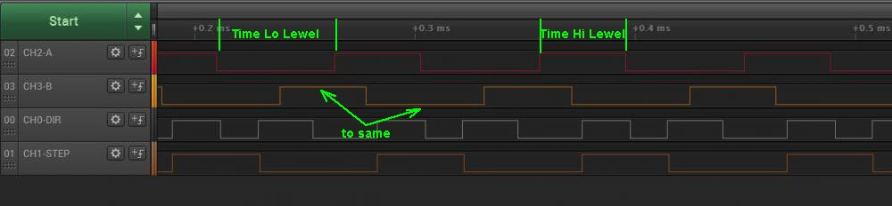
---
To make it absolutely beautiful, it is desirable to equalize the time intervals of the input signals,
Well and further under the text.

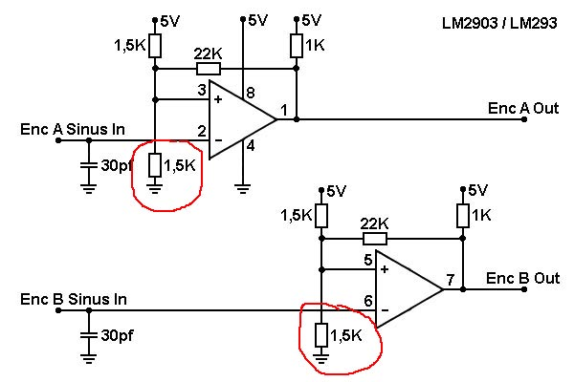

Cone Calculations

Ian, as before,
1. the coefficient can not be less than unity,
We still divide, only for the cone is not the encoder, but the steps are longitudinal by the coefficient. Get the steps for the transverse.
To be more precise, we calculate the step for the longitudinal one from the encoder, and the step of the longitudinal one (one axis "pulls" the second one), this is done for synchronous acceleration and deceleration for the same trajectory of the motors on the accelerated,
So we are limited to the maximum cone, on my gland this is about 33.7 grams. From the axis of the spindle, the opening angle of the cone is 2 times greater, respectively.
2. {1, 0723, "25deg"} as before remove an insignificant zero, {1, 723, "25deg"}
3. Have you changed the longitudinal screw on the machine to the screw step 2mm ?, on my iron (and how much I remember you had 1 in 1):
{1, 4297, "25deg"}, the cone angle will be 50gr.

Acceleration settings
Can you explain what the numbers are, 125, 15, 32, in the acceleration settings.
16000000/32 = constant 500kHz, the clock frequency of the timer on which the accelerated feed operates,
The rest is in the comments.

It's strange,
The parameters on the driver must of course match the parameters in the program:
MOTOR_Z_STEP_PER_REV 200
McSTEP_Z 4
On the driver: 800
Try these very soft options:
// Accelerated Displacements
#define MAX_RAPID_MOTION 50
#define MIN_RAPID_MOTION (MAX_RAPID_MOTION + 200 )
#define REPEAt (McSTEP_Z * 4 )
Starting 75minutes
Maximum
Acceleration time 400 full steps (2 motor revolutions)
It should earn on almost any bundle motor driver
If it does, we shorten the overclocking:
#define REPEAt (McSTEP_Z * 2 )
This is 1 full revolution of the motor, too, should not be a problem
If it does, we increase the final speed (and at the same time the start speed slightly increases, but the duration of the acceleration remains unchanged):
#define MAX_RAPID_MOTION 48 (46, 44, 42, ..)
Before failure, for the current REPEAt it will be "near the ceiling", return a little back
If it does, we increase the starting speed (at the same time the acceleration time decreases, but the final speed remains unchanged)
#define MIN_RAPID_MOTION (MAX_RAPID_MOTION + 190 (180, 170, 160, ...))
Have achieved stability, run between the stops with an indicator,
In one direction by normal feed, in reverse accelerated, a dozen times is enough, the indicator readings are stable, recorded all 3 parameters on a piece of paper and try the following option
I would recommend doing and trying 3 variants with different overclocking times:
#define REPEAt (McSTEP_Z * 1, 2, 4 )
Shorter acceleration - a smaller achievable speed and vice versa, you can like any of the options.

Electronic Stops
What kind of fence is it and where are they put on the machine?
Electronic stops brought to the right place, pressed the button, everything
The subport will stop at this place, also in the other direction.
Pressed again took off the stop, the LEDs.

In the brains of the Arduin they are put and do not allow the pads to turn farther than a certain turn in one direction. They obviously only work when you control the pegs from the guitar, when you rotate the screw with your hands - they move out.

Menu Encoders
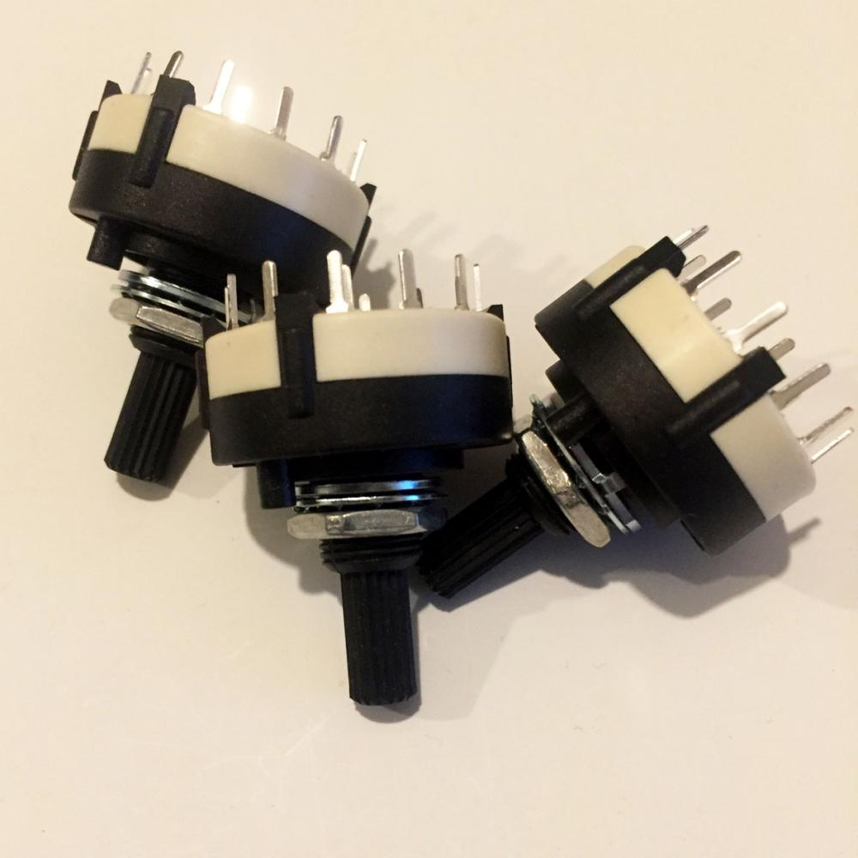
Not Jan, there are no schemes yet, in words:
Menu buttons A0-A4, switching to the general
Variable A7, the extreme ends by +5 and the total, according to power supply, a capacitor of 0.1μf is desirable
Switch_1 22-29, switching to the general
Switch_2 51-53, switching to the general
All the contacts gave on the marking on the board,
On all buttons and switches it would be necessary an external brace, I while put only on buttons, switches while bezglyuchno work on an internal suspender.
It seems that I have not forgotten anything.

Stop Buttons (Electronic Limit Switches?)

strongly recommend installing these buttons directly near the joystick.
Fall in my pictures,
Buttons near the indicator - menu
Near the joystick - the stops, on the extreme picture you can see which ones are installed.
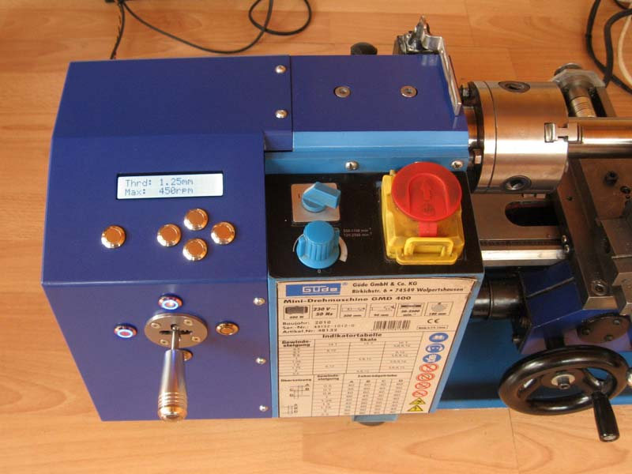

Changes for the future 7th version:
Menu Buttons:
Select - Port F0 - ADC0
Left - Port F1 - ADC1
Down - Port F2 - ADC2
Up-Port F3-ADC3
Right - Port F4 - ADC4
Mode switch, 8 pos:
The extreme left position is Port A0 - 22
...
The extreme right position is Port A7 - 29
Sub-mode switch, 3 pos:
The extreme left position is Port B0 - 53
...
The extreme right position is Port B2 - 51
Variable resistor:
The extreme ends of +5, the total
Medium - Port F7 - ADC7
LCD Connection:
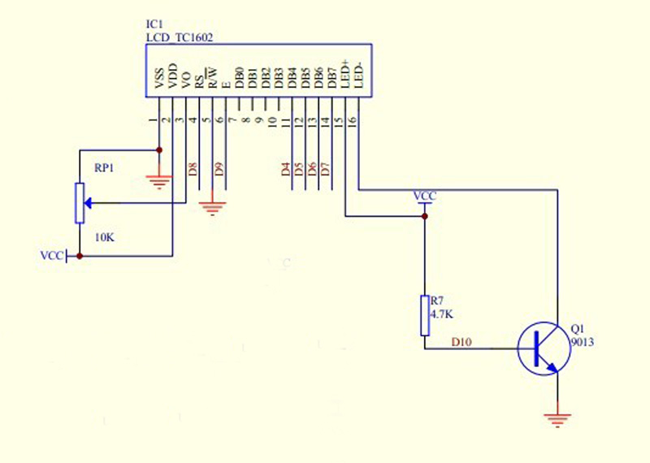

The red D8, D9, D4, D5, D6, D7 are 8, 9, 4, 5, 6, 7 pin contacts on the Mega top comb, the transistor is not needed for backlighting.

